Day 2 Activity 2 Worksheet
- Matching words with pictures:

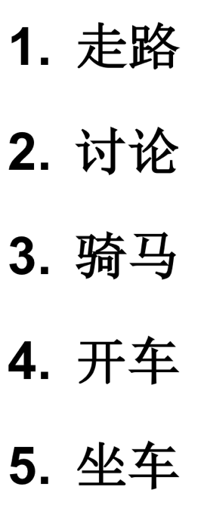 | 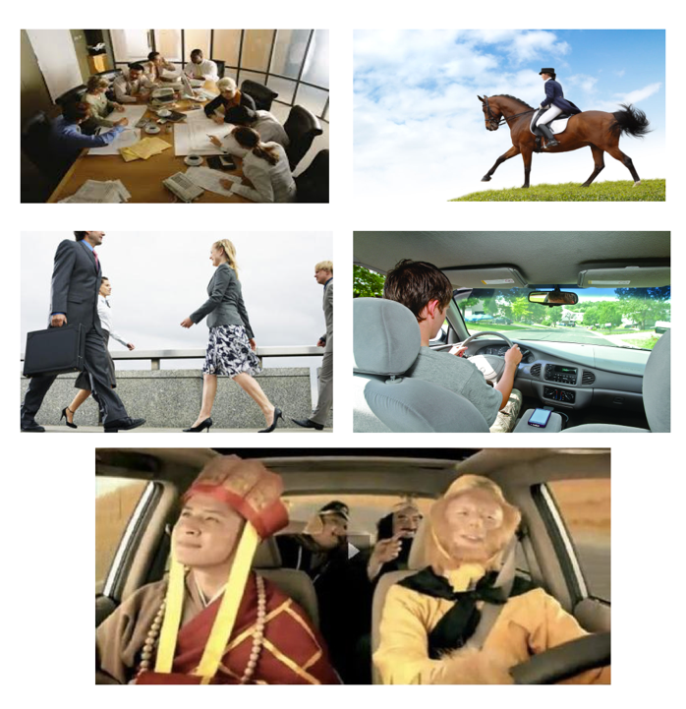

(2) 扩词 Word & Phrase Expansion

(a)动词 Verbal Phrase | (b)名词词组 Noun Phrases

- 扩词到句Matching pictures with sentences.

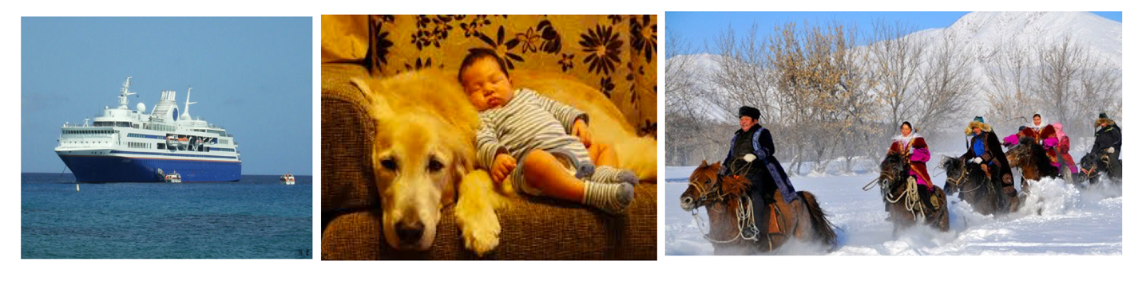

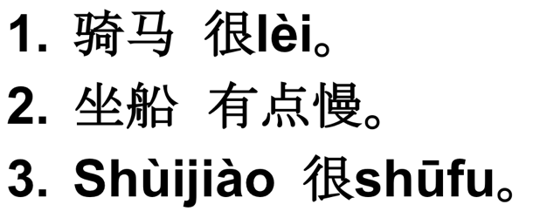

- 扩词到句 Match the pictures with correct verb phrase, and say aloud the complete sentences to respond to the question, “他想怎么去？”.

